**Appendix 1:Summary of advice in the NICE guideline on type 2 diabetes management**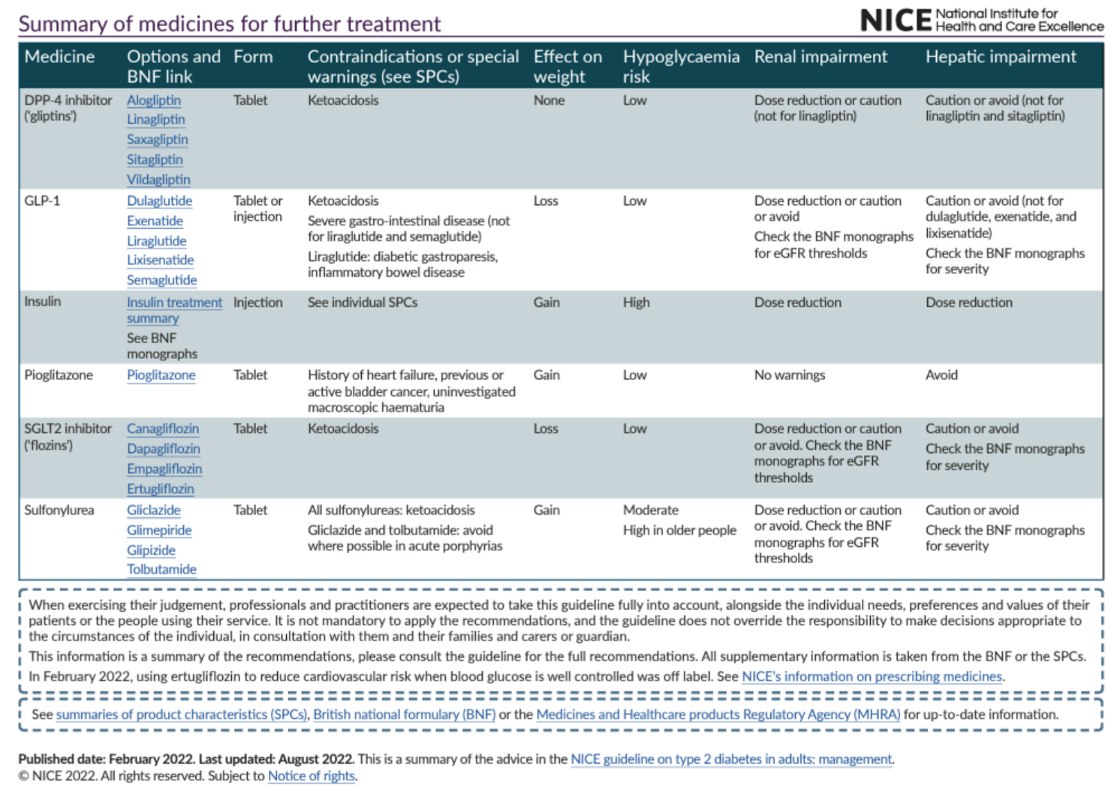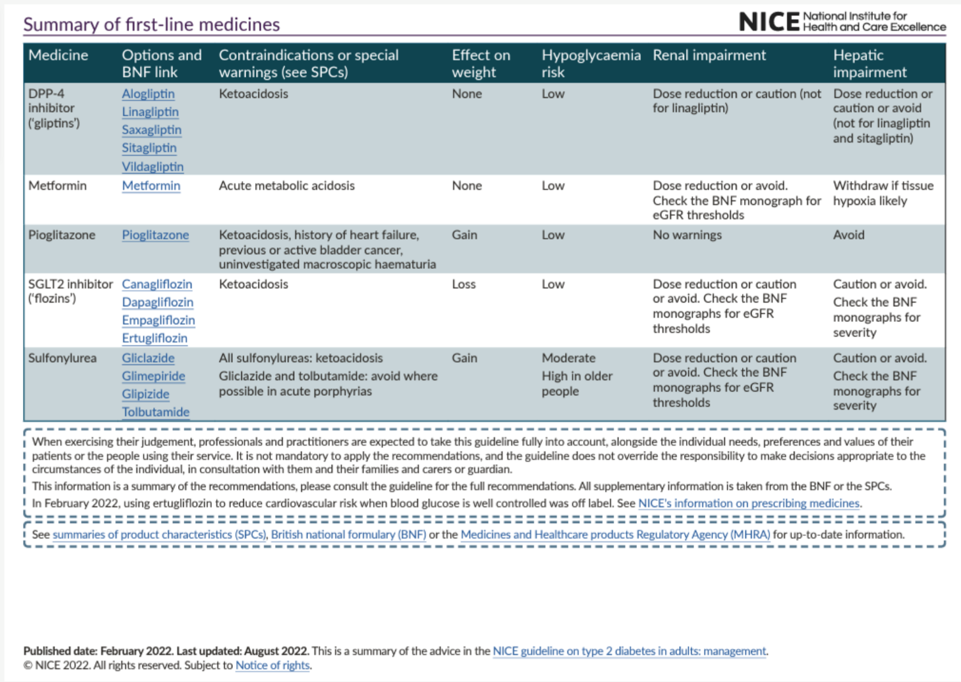

**Appendix 2: Diabetes UK Information Prescription: Diabetes and Kidney Disease**

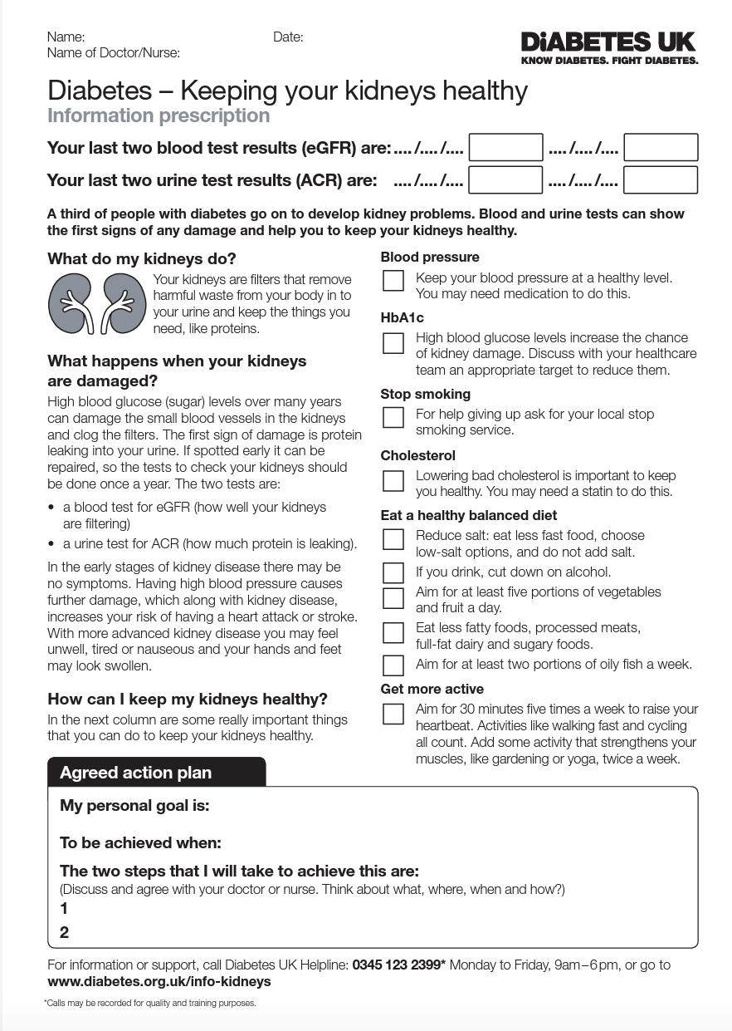

This PDF can be accessed at <https://www.diabetes.org.uk/resources-s3/2017-08/0655C%20GP%20Information%20Prescriptions_Healthy%20Kidney_v6.pdf>

Source: <https://www.diabetes.org.uk/>

**Appendix 3: Antihyperglycaemics Deprescribing Algorithm (deprescribing.org)**

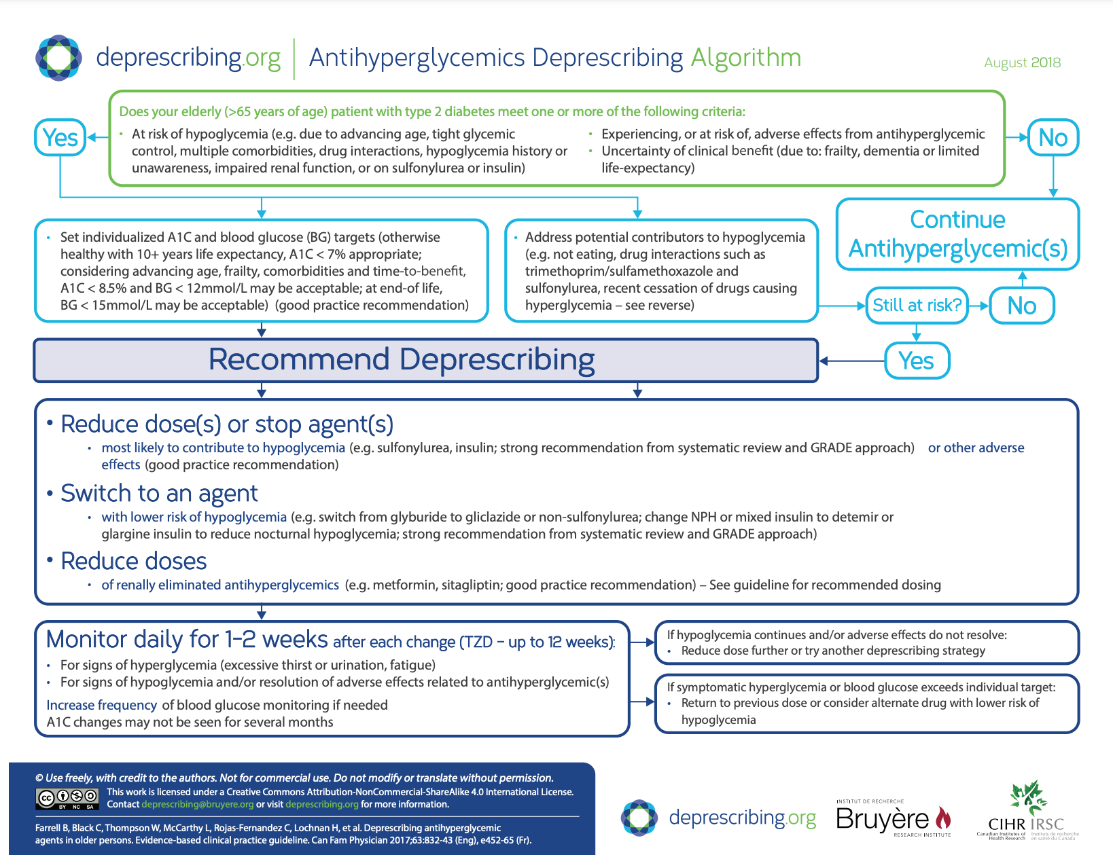

**Appendix 4 - Patient Decision Aid for HbA1c targets (**[**https://www.nice.org.uk/guidance/ng28/resources/patient-decision-aid-pdf-2187281198**](https://www.nice.org.uk/guidance/ng28/resources/patient-decision-aid-pdf-2187281198)**)**



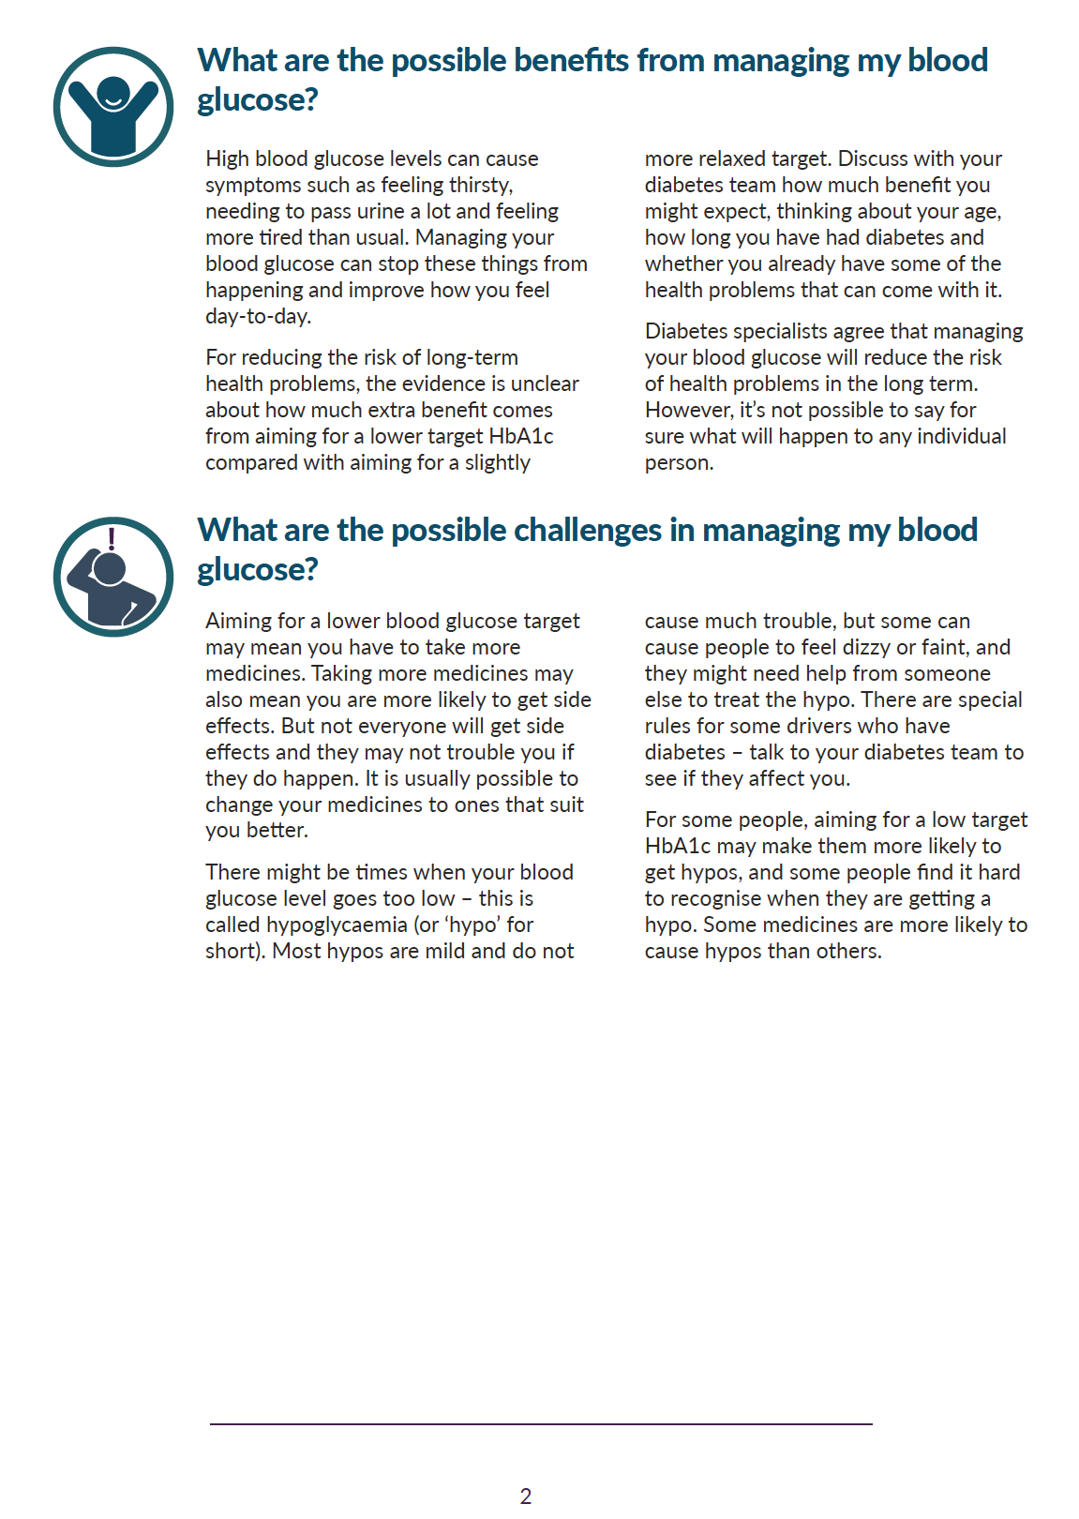

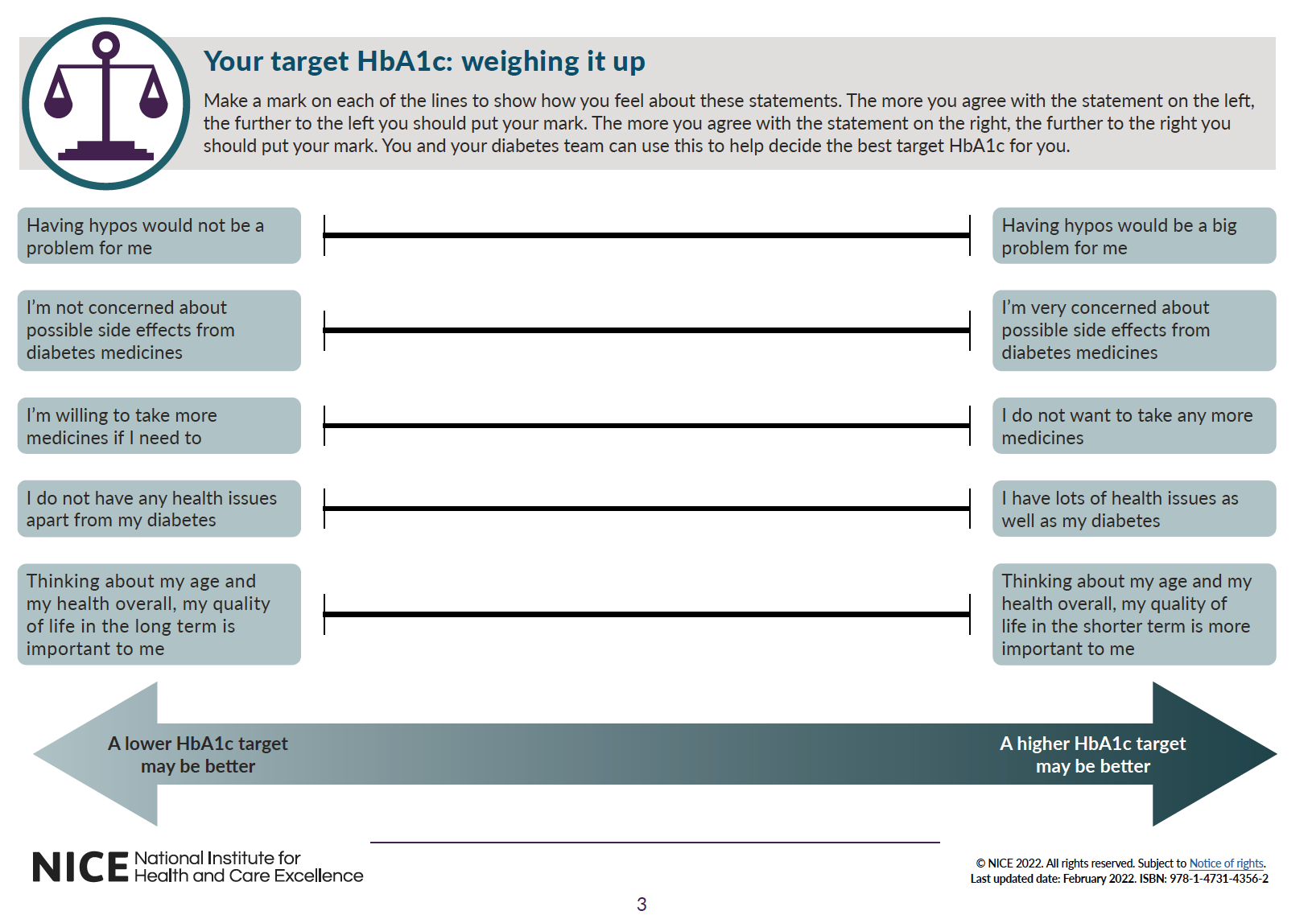

**Appendix 4 continued – Deprescribing leaflet for patients**

**(**[**https://deprescribing.org/wpcontent/uploads/2018/08/deprescribing_pamphlet2018_AHG_v03.pdf**](https://deprescribing.org/wpcontent/uploads/2018/08/deprescribing_pamphlet2018_AHG_v03.pdf)**)**

